**31.** **Poisson Distribution**

**Aim :**

To write an R program to perform Poisson distribution calculations using **ppois**, **dpois**, and **rpois** functions for probabilities.

**Algorithm :**

**Step 1 :** Start the process to perform Poisson distribution calculations using ppois, dpois, and rpois functions.

**Step 2 :** Calculate cumulative probability using ppois() for given values with both tail options.

**Step 3 :** Calculate exact Poisson probability for a specific event count using the Poisson formula.

**Step 4 :** Determine probabilities for multiple event counts using Poisson probability function.

**Step 5 :** Generate random samples from the Poisson distribution for simulation purposes.

**Step 6 :** Compare probabilities and samples to verify they follow Poisson distribution characteristics.

**Step 7 :** End of the Program

**Program :**

#ppois

a = ppois(16,lambda = 12,lower.tail = TRUE)

b = ppois(16,lambda = 12,lower.tail = FALSE)

print(a+b)

#dpois

n=3000

p=0.001

r=6

lambda = n*p

b<-exp(-lambda)*lambda^6/factorial(6)

print(b)

dpois(6,lambda)

k1<-dpois(0,lambda)

k2<-dpois(1,lambda)

k3<-dpois(2,lambda)

k4<-dpois(3,lambda)

k5<-dpois(4,lambda)

k6<-dpois(5,lambda)

c<-paste(k1," ",k2," ",k3," ",k4," ",k5," ",k6," ")

print(c)

print(k1+k2+k3+k4+k5+k6)

ppois(3,lambda,lower.tail = TRUE)

ppois(3,lambda,lower.tail = FALSE)

lambda <- 12

samples <- rpois(10, lambda)

print(samples)

**Output :**

1. **Using Formula**

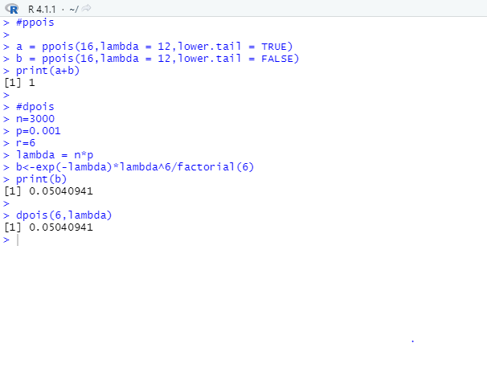

1. **Using dpois,ppois,qpois**

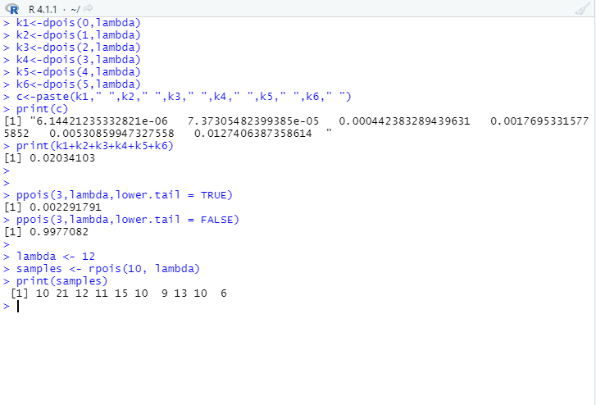

**RESULT:**

This, our program has been successfully saved and executed.